**1. What is XPath?**

XPath (XML Path Language) is a query language for selecting nodes in an XML document.

In Odoo, XPath expressions are used in view inheritance to target specific elements in existing views (e.g., adding/removing fields, modifying attributes).

**2. Basic XPath Syntax**

**Key Components**

* **/**: Selects from the root node.
* **//**: Selects nodes anywhere in the document.
* **[@attribute]**: Filters nodes by attribute.
* **element[@attribute='value']**: Selects nodes with a specific attribute value.
* **position()**: Filters by position (e.g., first, last).
* **|**: Combines multiple expressions.

**3. Using XPath in Odoo View Inheritance**

**Step 1: Create an Inherited View**

Define a new XML record in your module to inherit an existing view:

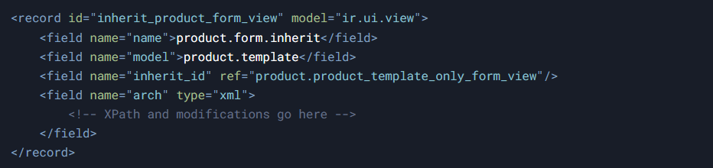

**Step 2: Write the XPath Expression**

Use XPath to locate the element you want to modify.

Example: Add a field `my_custom_field` after the `description` field in a form view.

**Original View Snippet:**

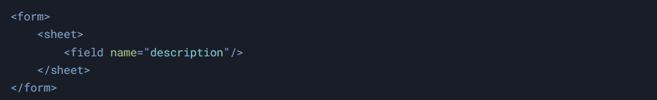

**XPath in Inherited View:**



**Step 3: Use position Attribute**

**position** defines where the modification is applied:

* **inside** (default): Appends content inside the node.
* **after**: Inserts after the node.
* **before**: Inserts before the node.
* **replace**: Replaces the node.
* **attributes**: Modifies node attributes.

**Shortcut Syntax**:

Instead of XPath, use the element name and `position` directly:

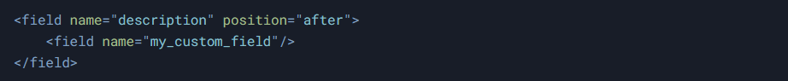

**4. Common Use Cases**

**Add a Field**



**Modify an Attribute**

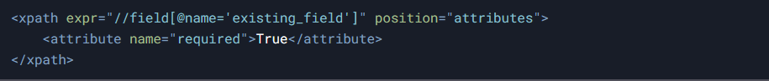

**Replace a Node**

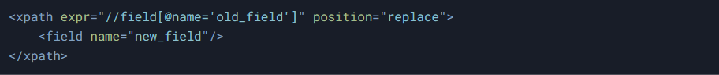

**Insert a Group**

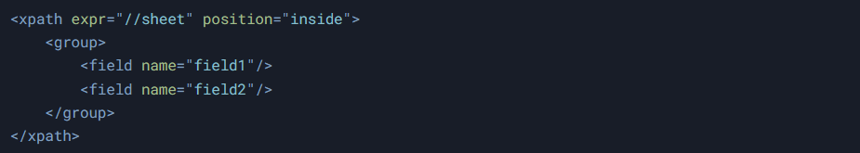

**5. Advanced XPath Examples**

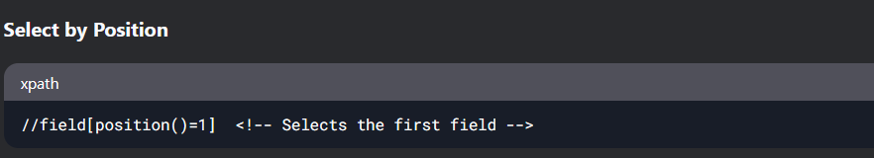

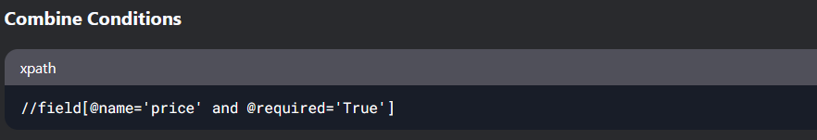

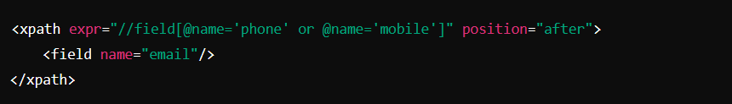

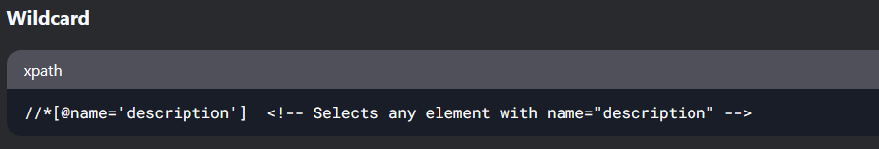

**Note:** Use **Odoo Developer Mode** → **Edit View** to inspect the XML structure.

**pdf or html template url**

**=========================**

http://localhost:1575/report/pdf/account.report_invoice_with_payments/1710